Thank you for choosing to utilize the electronic timesheet feature! This document tells providers how to use the e-timesheet system (there are separate instructions for participant/families).

The web portal registration process is quick and simple. Just follow the instructions in the ‘Online User Registration’ link on https://fms.publicpartnerships.com/PPLPortal/Login.aspx. You will receive a username and password which you will then use to access the web portal and begin submitting timesheets and invoices electronically.

As a provider, there are two things that you can do by using the e-timesheet system:
- Complete timesheets online and submit them either electronically or on paper
- View the status of your timesheets

This document will provide you with instructions on completing these tasks.

Completing Online Timesheets

- Go to https://fms.publicpartnerships.com

- Enter your user name and password and click Login. Remember that your user name and password are case sensitive.
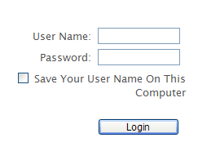

- The system will bring you to the Timesheet List screen. Click on the Create Timesheet option.
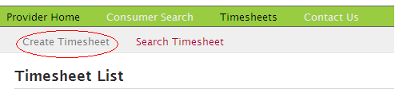

- The ‘Create Timesheet’ menu option provides you with a list of the participants for whom you work. Most people will only have one participant listed but some providers may work for multiple participants. They will all be listed on the screen.

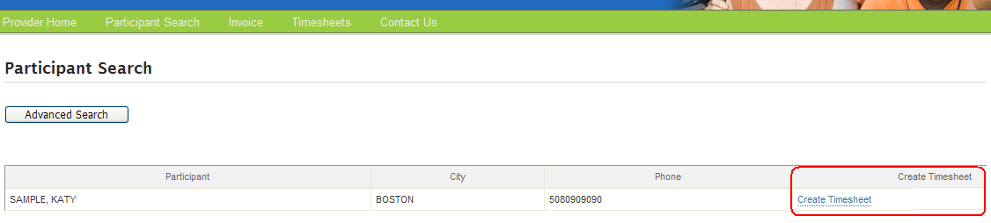

- Click on the Create Timesheet option.

- By clicking on “Create Timesheet”, you will be taken to a screen like the one shown below. Select the date for which you would like to submit time by clicking on the calendar icon. Please note: Even if you do not pick a date that is not the start of a pay period, the system will create a timesheet that starts with the first day of the pay period that includes the date you selected. For example, the pay periods for this program start every other Sunday. If you select a day other than Sunday from the calendar below, the first day on the timesheet would be the first day of that pay period.

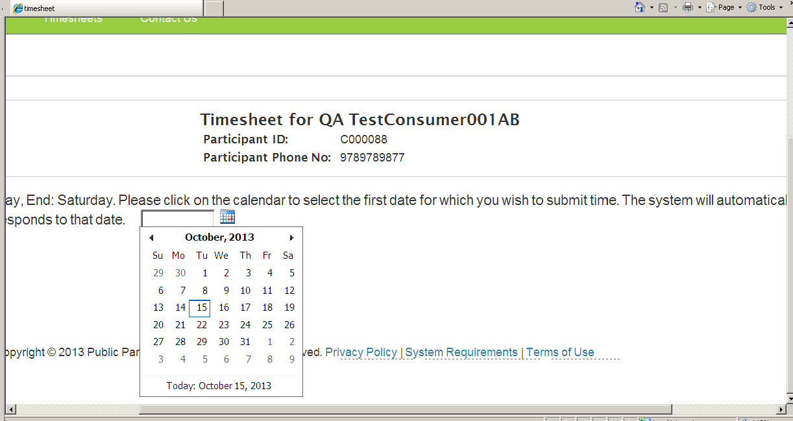

- After you select the date, a service drop down box will appear at the top. If there is one common service you would like to appear, select from the service drop down box. The service will populate on all dates. If you are submitting a timesheet that has multiple services, leave this box blank.

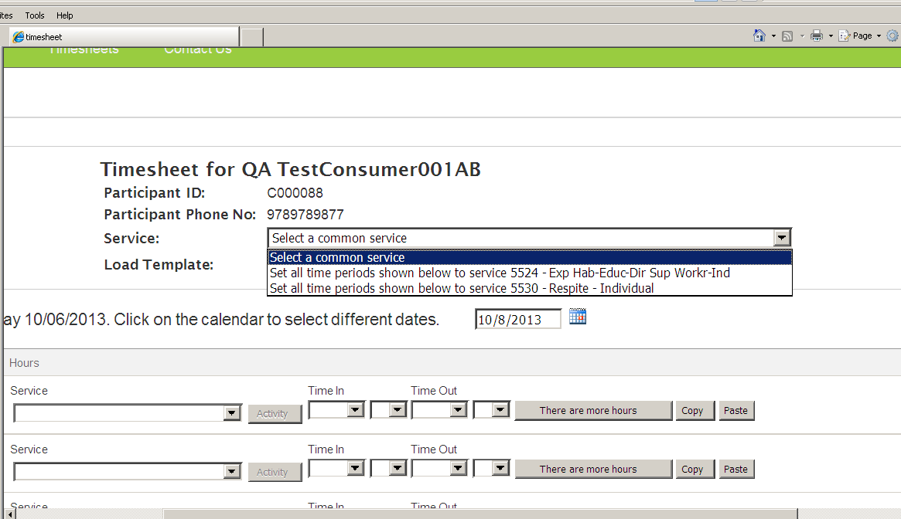

- Enter the time in and time out by clicking on the drop down menus. The first drop down allows you to select the hour and the second drop down allows you to select the minutes. In the example below, the provider started working at 12 am on October 06, 2013. Next, select the ‘service’ type on the drop down menus for each day if you are submitting a multi-service timesheet. If you selected a common ‘service type’ this should already be pre-populated with the service type.

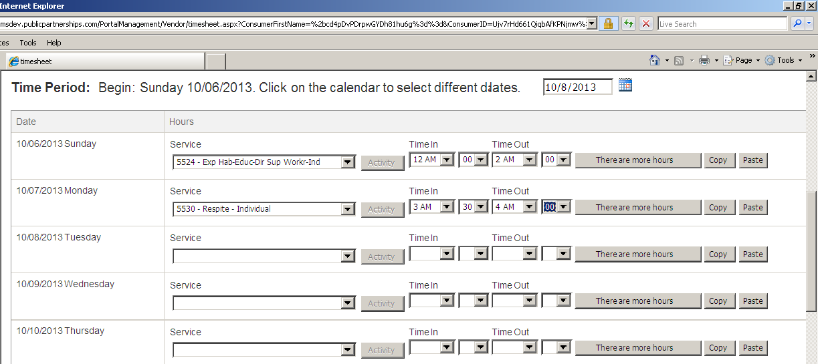

- If you start and stop work multiple times during a day, select the “There are more hours” button to add more time.

- When you are finished, go to the bottom of the screen and click on the Next button.

- The system will produce an overview of the timesheet and sum up the hours submitted.

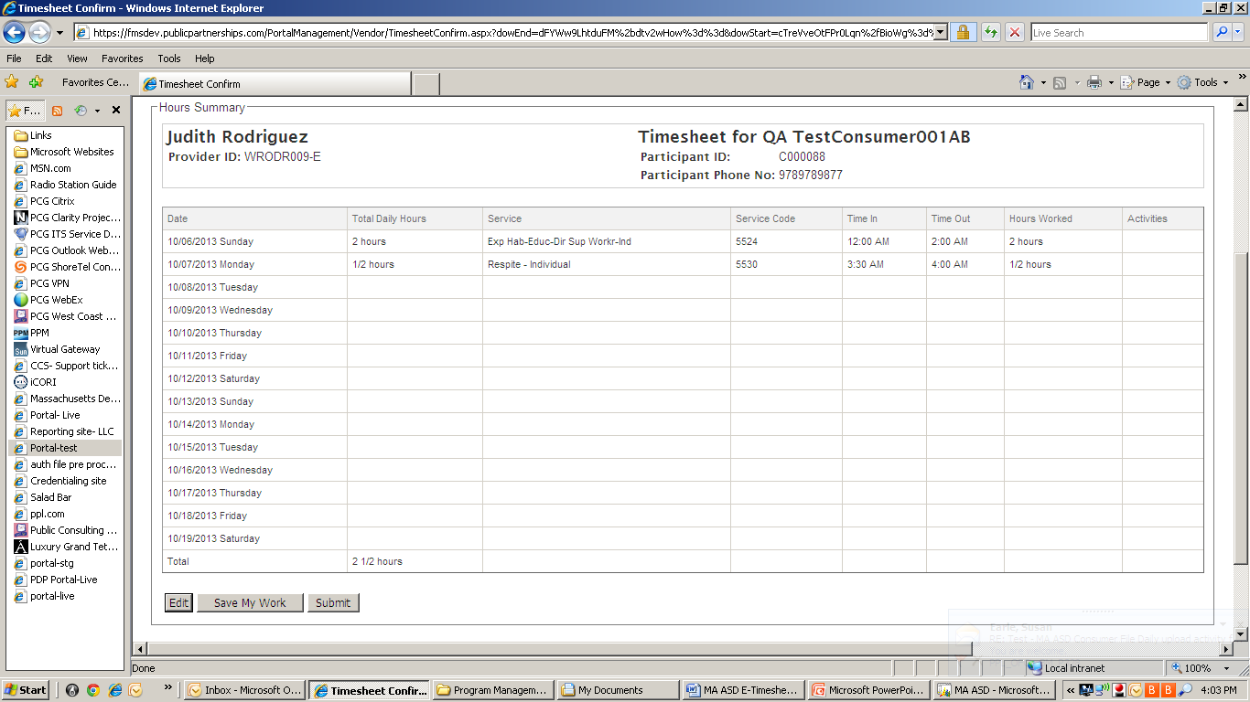

- At this time, you have the option of changing the timesheet (by choosing Edit), saving what you have done so that you add more to this same timesheet later on (by choosing Save My Work) or submitting the timesheet to your participant/family (by choosing Submit). PLEASE NOTE: Choosing Submit will send the timesheet to your participant/family for their approval.

- When you choose Submit, the system will test the timesheet against the MA Autism Waiver Program rules for payment. If the system believes that the timesheet (or the participant or provider paperwork) does not meet MA AWP rules for the program, you will see an error on the screen. These errors are called pend messages. If a pend message appears after you choose Submit, your timesheet has not been successfully submitted. The items in the pend message must be resolved before the timesheet can be submitted successfully. Please contact your MA AWP Support Broker or PPL Customer Service for any questions surrounding pend messages.

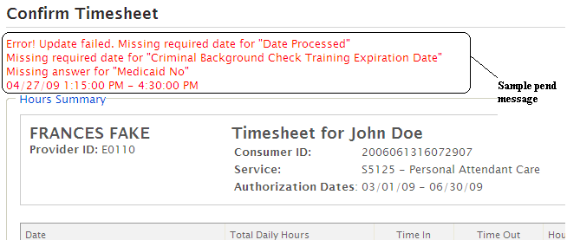

- If the timesheet, your paperwork and the participant’s paperwork meets all MA AWP rules, after hitting submit, you will see a screen like the one below:

- If the participant/family for whom you work is going to approve your timesheet electronically, you are done. Congratulations!

- If you are going to print out the timesheet, have your participant sign it and fax it in or file it for your records, you have one more step. Go to the bottom of the screen and select “Show printable version (PDF).” This will load a pdf version of the timesheet that you can print out. There are two important things to remember when choosing the print option:

  - You and the participant you work for (or his/her representative) must sign the timesheet before it is faxed in. PPL will not pay a timesheet without signatures.
  - The fax number for timesheets completed on the web and then faxed to PPL is different than the regular number you use to fax in timesheets. Make sure to use the number on the timesheet.

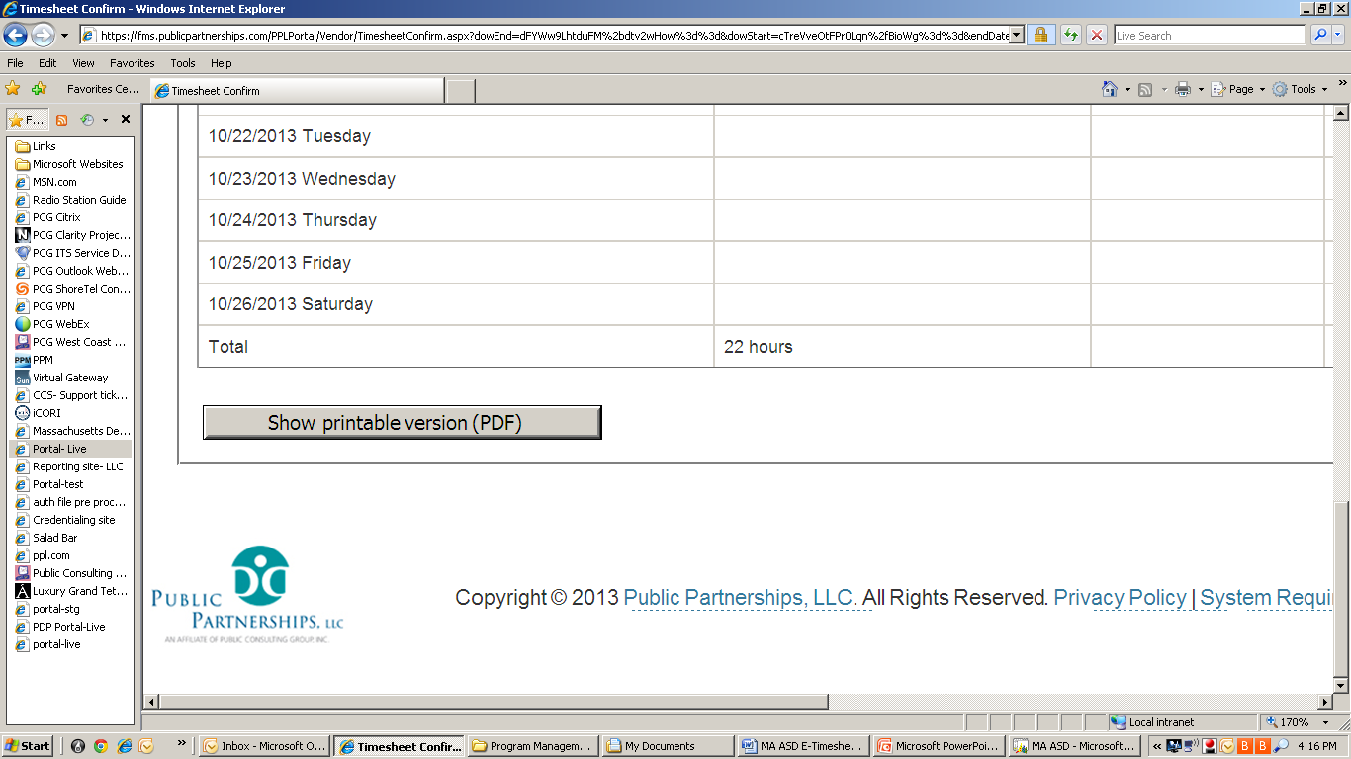

Viewing the Status of Timesheets

You can use the e-timesheet system to see if your timesheets have been approved by the participant/family you work for, what timesheets PPL has received, the mode by which we have received them (over the Internet or via fax/mail), and if the timesheet has been paid.

- Go to https://fms.publicpartnerships.com

- Enter your user name and password and click Login. Remember that your user name and password are case sensitive.

- The system will bring you to the Timesheet List screen. This screen lists all timesheets that you have submitted for payment. The timesheets are sorted in order of timesheet start date with the most recent start date at the top of the page.

- The “Status” column provides information about the status of timesheets you have submitted.
  - A timesheet that has been submitted electronically by the provider but not yet approved by the participant/family has a status of Submitted.
  - A timesheet that has been faxed and is being processed has a status of In Process.
  - A timesheet that has been submitted electronically by the provider, approved for payment and will be paid in the next pay cycle has a status of Good to Pay.
  - A timesheet that has been submitted electronically by the provider and rejected by the participant/family has a status of Rejected.
  - A timesheet that has been paid has a status of Paid and has a check number listed.

Please note: PPL cannot pay an electronic timesheet until it has been approved by your participant/family.

- You can view any timesheet in the list by clicking the View button on the left-hand side. It will provide you with a detail listing of the time submitted.
- You can edit timesheets that have been submitted to the participant/family but have not yet been approved by selecting the Edit button.

- You can print off timesheets by clicking on the ‘Show Printable Version’ button. This will produce a pdf copy of the timesheet, which you can then print if you would like.

We thank you for using the electronic timesheet feature, and urge you to contact PPL Customer Service at 866-315-3740 with any questions you may have.

